Algebra 3-4 Name: _______________________
Worksheet 1.4 Block: ______

Find the value of y.

1. 3x – 7y = 8 when x = -2 2. x = 12 – xy when x = 4

3. 5x + 2y = 8 when x = -1 4. 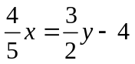 when x = 10

5. 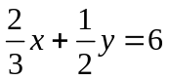 when x = 6 6. 2x + 3y = 1 when x = -1

7. 6x – 9y = 9 when x = -3 8. -3x + 7 = 2y + 3 when x = 4

9. 8x + 3y = 10 when x = 4 10. 2 + xy = 5x when x = -1

11. 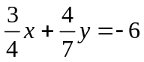 when x = 8 12. 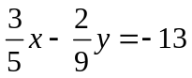 when x = 15

Solve the formula for the indicated variable.

13. Solve for s: 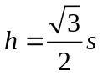 14. Solve for s: 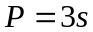

15. Solve for h: 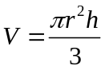 16. Solve for C: 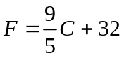

17. Solve for h: 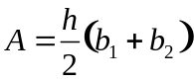 18. Solve for 

